HOW TO UPDATE THE FIRMWARE ON TRAULUX MONITORS.
Copy the .bin file containing the firmware to an empty USB key in FAT32 format. It usually takes about 2 GB. The USB key should not be larger than 32 GB, better 8 or 16 GB. (The file can be named something like DZ81Upgrade.bin or something similar). Each monitor model has a different firmware.
Procedure with the front button panel of the monitor:
1-Turn off the monitor and connect the USB pen with the firmware in the side port (not front) where the wifi is connected.
2- Turn on the monitor keeping the power button pressed until the update process starts. Do not turn off the screen during the installation which may take about ten minutes. The screen will restart at the end.
Procedure with the remote control (remote control):
1-Turn off the monitor and plug the USB pen with the firmware into the side port (not front) Where the wifi is connected.
2-Use the remote control or remote control to turn on the monitor, pressing several times in a row quickly the start button or power, until the update process begins and you see the progress bars. The upgrade process may take about ten minutes.
Here are the three TRAULUX monitor models we have now:
TLM80 If you click on the "Input Sources" button you will see that it does NOT have a VGA port.
TLM80-1 In the input sources you will see that it already has a VGA port.
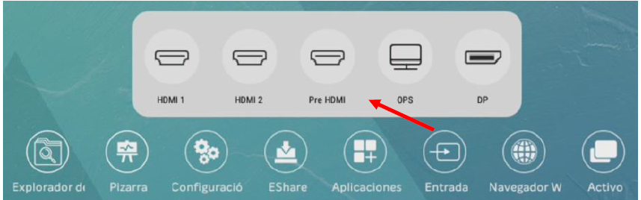
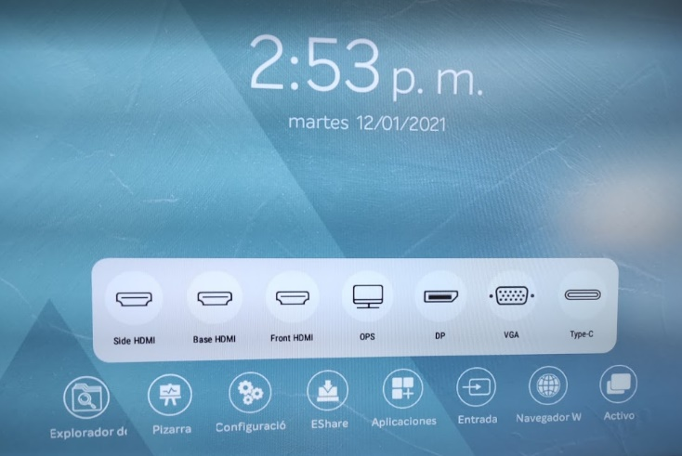
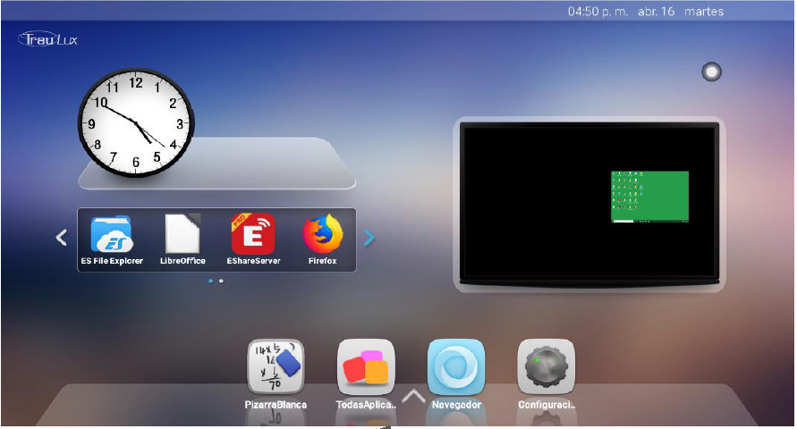
TLM You can see that the input screen (the Desktop) is totally different.
TLM80
TLM80-1
TLM

The update process is practically the same for all three models, but be careful, each model has its own firmware that should not be confused.

